All About Enterprise Basic Searching

The simplest way to search in Enterprise is to type a search term in the search box and hit Enter or click the “Search” button.

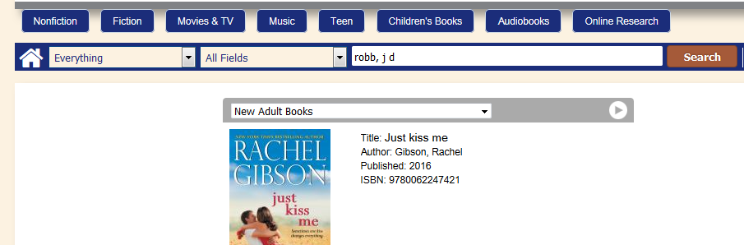

If you like, you can search for specifically a title or author by clicking on the “All Fields” dropdown and changing the field from “All Fields” to the field you’d like to search for. In this case, it would probably be a good idea to change the search to an “Author” search:
Highlight and click “Author”:

The search results that appear for this search:
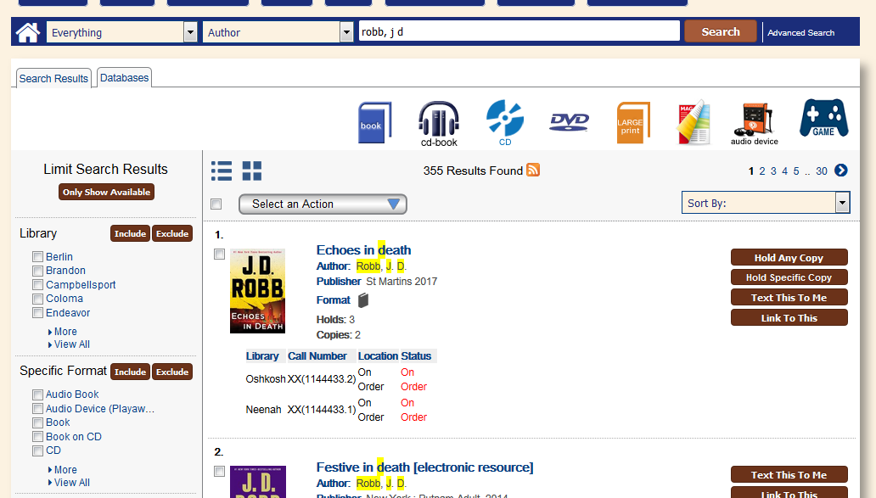

Use the list of numbers and the right arrow on top and bottom right of the search results to see more results:
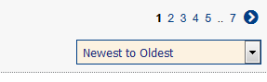

Holding information (which library owns the book) can be seen under the item’s summary information.
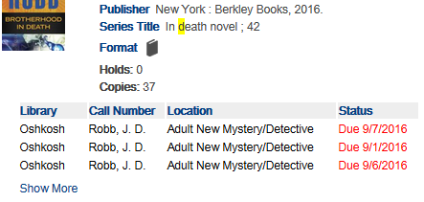
This holding information also lists the call number, shelf location, and Status, with the chosen (Profile) library’s items being on top of the list. Only the first few lines of the holding information will be shown by default.
If you would like to see more holdings, click the blue “Show More” text:
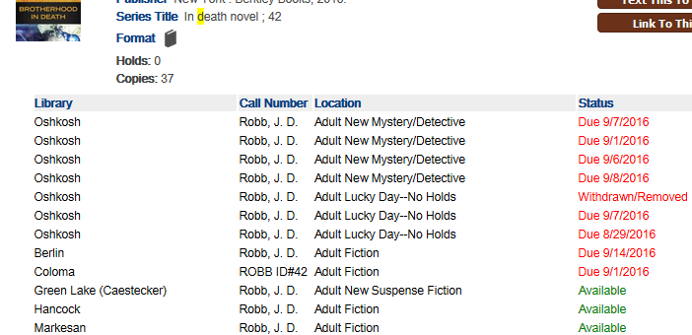

To see more information about an item, click on the item’s title in blue:
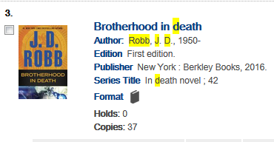

This will open a window that will show more information about the item.
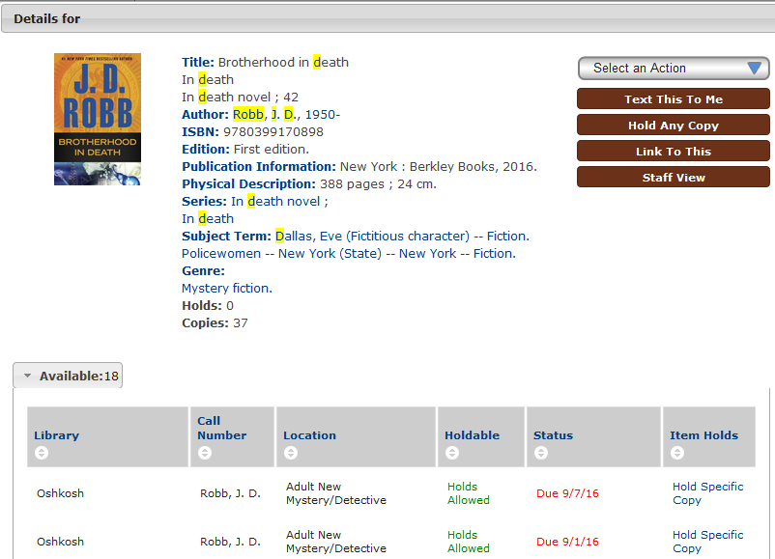

From this detail page, you can click the blue and white arrows to the left and right of the window to move to the next record without going back to the search results:
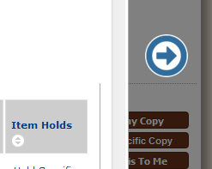

Holding information is open by default beneath the item’s information. As on the search results page, it will list libraries who own the item, where the item is located in the library, if it’s available, and if the library allows holds on an item or if it’s a Local Hold Only item (in the “Holdable” column). For example:
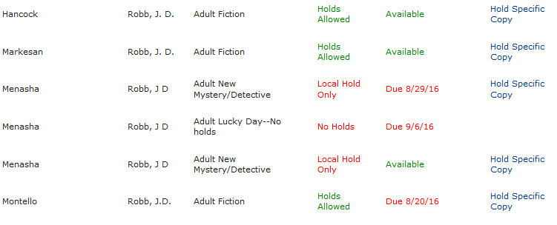
Hancock’s copy is available, and able to be held by anyone. Menasha’s third copy is available as well, but can only be placed on hold by Menasha patrons.

If the holding information is very long, it can be collapsed by clicking on the Available tab:
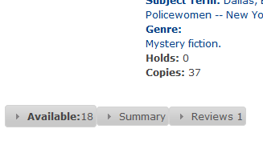
This allows easier access to any Summaries and Reviews of the item. Any of these tabs can be expanded by clicking on them:
